CSS Syntax

A CSS rule-set consists of a selector and a declaration block:

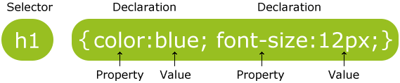

The selector points to the HTML element you want to style.

The declaration block contains one or more declarations separated by semicolons.

Each declaration includes a CSS property name and a value, separated by a colon.

A CSS declaration always ends with a semicolon, and declaration blocks are surrounded by curly braces.

The id Selector

To select an element with a specific id, write a hash (#) character, followed by the id of the element.

|  |  |
| --- | --- |
| **Note** | **Note:** An id name cannot start with a number! |

## The class Selector

To select elements with a specific class, write a period (.) character, followed by the name of the class.

## Grouping Selectors

To group selectors, separate each selector with a comma.

## CSS Comments

Comments are used to explain the code, and may help when you edit the source code at a later date.

## Three Ways to Insert CSS

There are three ways of inserting a style sheet:

* External style sheet
* Internal style sheet
* Inline style

|  |  |
| --- | --- |
| **Note** | Do not add a space between the property value and the unit (such as margin-left:20 px;). The correct way is: margin-left:20px; |

<link type="text/css" rel="stylesheet" href="mystyle.css"/>

## Color Names

Cyan

**Note:** Color names are case-insensitive: "Red" is the same as "red" or "RED".

## RGB (Red, Green, Blue)

RGB color values can be specified using this formula: rgb(red, green, blue).

Each parameter (red, green, blue) defines the intensity of the color between 0 and 255.

## Hexadecimal Colors

RGB values can also be specified using **hexadecimal** color values in the form: #RRGGBB, where RR (red), GG (green) and BB (blue) are hexadecimal values between 00 and FF (same as decimal 0-255).

# CSS Backgrounds

The CSS background properties are used to define the background effects for elements.

CSS background properties:

* background-color
* background-image
* background-repeat
* background-attachment
* background-position

background: *bg-color bg-image position/bg-size bg-repeat bg-origin bg-clip bg-attachment*initial|inherit;

background-attachment: scroll|fixed|local|initial|inherit;

background-clip: border-box|padding-box|content-box|initial|inherit;

background-size: auto|*length*|cover|contain|initial|inherit;

background-origin: padding-box|border-box|content-box|initial|inherit;

## CSS3 Multiple Backgrounds

CSS3 allows you to add multiple background images for an element, through thebackground-image property.

The different background images are separated by commas, and the images are stacked on top of each other, where the first image is closest to the viewer.

background-image: url(img_flwr.gif), url(paper.gif);

## Border Style

The border-style property specifies what kind of border to display.

The following values are allowed:

* dotted - Defines a dotted border
* dashed - Defines a dashed border
* solid - Defines a solid border
* double - Defines a double border
* groove - Defines a 3D grooved border. The effect depends on the border-color value
* ridge - Defines a 3D ridged border. The effect depends on the border-color value
* inset - Defines a 3D inset border. The effect depends on the border-color value
* outset - Defines a 3D outset border. The effect depends on the border-color value
* none - Defines no border
* hidden - Defines a hidden border.(same to none, but use to solve table comflict. W3cschool)

A dotted border.

A dashed border.

A solid border.

A double border.

A groove border. The effect depends on the border-color value.

A ridge border. The effect depends on the border-color value.

An inset border. The effect depends on the border-color value.

An outset border. The effect depends on the border-color value.

No border.

A hidden border.

A mixed border.

## CSS3 border-radius Property

With CSS3, you can give any element "rounded corners", by using the border-radiusproperty.

## CSS3 border-radius - Specify Each Corner

If you specify only one value for the border-radius property, this radius will be applied to all 4 corners.

However, you can specify each corner separately if you wish. Here are the rules:

* **Four values:** first value applies to top-left, second value applies to top-right, third value applies to bottom-right, and fourth value applies to bottom-left corner
* **Three values:** first value applies to top-left, second value applies to top-right and bottom-left, and third value applies to bottom-right
* **Two values:** first value applies to top-left and bottom-right corner, and the second value applies to top-right and bottom-left corner
* **One value:** all four corners are rounded equally

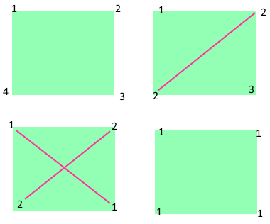

## CSS3 border-image Property

The CSS3 border-image property allows you to specify an image to be used instead of the normal border around an element.

The property has three parts:

1. The image to use as the border
2. Where to slice the image
3. Define whether the middle sections should be repeated or stretched

border-image: *source slice width outset repeat*|initial|inherit;

|  |  |
| --- | --- |
| **Note** | **Tip:** The border-image property is actually a shorthand property for the border-image-source, border-image-slice, border-image-width, border-image-outsetand border-image-repeat properties. |

border-image-slice: *number*|*%*|fill|initial|inherit;

border-image-outset: *length*|*number*|initial|inherit;

border-image-repeat: stretch|repeat|round|initial|inherit;

**Note:** The border-image-outset/slice property can take from one to four values (top, right, bottom, and left sides). If the fourth value is omitted, it is the same as the second. If the third one is also omitted, it is the same as the first. If the second one is also omitted, it is the same as the first.

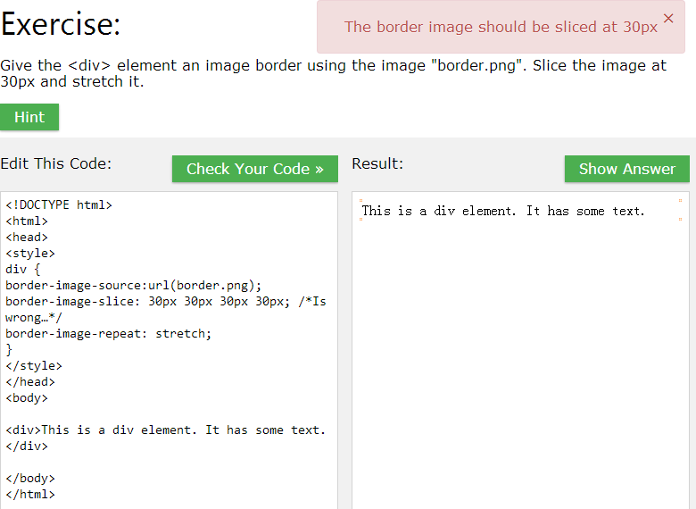

border-image-slice: 30;

CSS Margins

The CSS margin properties set the size of the white space OUTSIDE the border.

|  |  |
| --- | --- |
| **Note** | **Note:** The margins are completely transparent - and cannot have a background color! |

With CSS, you have full control over the margins. There are CSS properties for setting the margin for each side of an element (top, right, bottom, and left).

|  |  |
| --- | --- |
| **Note** | **Note:** It is also possible to use negative values for margins; to overlap content. |

CSS Padding

The CSS padding properties define the white space between the element content and the element border.

The padding clears an area around the content (inside the border) of an element.

|  |  |
| --- | --- |
| **Note** | **Note:** The padding is affected by the background color of the element! |

With CSS, you have full control over the padding. There are CSS properties for setting the padding for each side of an element (top, right, bottom, and left).

Setting height and width

The height and width properties are used to set the height and width of an element.

The height and width can be set to auto (this is default. Means that the browser calculates the height and width), or be specified in *length values*, like px, cm, etc., or in percent (%) of the containing block.

**Note:** The height and width properties do not include padding, borders, or margins; they set the height/width of the area inside the padding, border, and margin of the element!

# CSS Text

|  |  |
| --- | --- |
| **Note** | **Note:** For W3C compliant CSS: If you define the color property, you must also define the background-color property. |

## Text Alignment

The text-align property is used to set the horizontal alignment of a text.

**vertical-align: baseline|*length*|sub|super|top|text-top|middle|bottom|text-bottom|initial|inherit;**

**text-align: left|right|center|justify|initial|inherit;**

A text can be left or right aligned, centered, or justified.

When the text-align property is set to "justify", each line is stretched so that every line has equal width, and the left and right margins are straight (like in magazines and newspapers)

## Text Decoration

The text-decoration property is used to set or remove decorations from text.

**text-decoration: none|underline|overline|line-through|initial|inherit;**

The value text-decoration: none; is often used to remove underlines from links

|  |  |
| --- | --- |
| **Note** | **Note:** It is not recommended to underline text that is not a link, as this often confuses the reader. |

## Text Transformation

The text-transform property is used to specify uppercase and lowercase letters in a text.

**text-transform: none|capitalize|uppercase|lowercase|initial|inherit;**

## Text Indentation

The text-indent property is used to specify the indentation of the first line of a text.

## Letter Spacing

The letter-spacing property is used to specify the space between the characters in a text.

**letter-spacing: normal|*length*|initial|inherit;**

**white-space: normal|nowrap|pre|pre-line|pre-wrap|initial|inherit;**

## Line Height

The line-height property is used to specify the space between lines

## Text Direction

The direction property is used to change the text direction of an element.

**direction: ltr|rtl|initial|inherit;**

## Word Spacing

The word-spacing property is used to specify the space between the words in a text.

## CSS3 Text

CSS3 contains several new text features.

* text-overflow
* word-wrap
* word-break

The CSS3 text-overflow property specifies how overflowed content that is not displayed should be signaled to the user.

**text-overflow: clip|ellipsis|*string*|initial|inherit;**

|  |  |
| --- | --- |
| ellipsis | Render an ellipsis ("...") to represent clipped text |

The CSS3 word-wrap property allows long words to be able to be broken and wrap onto the next line.

**word-wrap: normal|break-word|initial|inherit;**

The CSS3 word-break property specifies line breaking rules.

**word-break: normal|break-all|keep-all|initial|inherit;**

|  |  |
| --- | --- |
| break-all | Lines may break between any two letters |
| keep-all | Breaks are prohibited between pairs of letters |

CSS3 Shadow Effects

With CSS3 you can add shadow to text and to elements.

* text-shadow
* box-shadow

The CSS3 text-shadow property applies shadow to text.

**text-shadow: *h-shadow v-shadow blur-radius color*|none|initial|inherit;**

**Note:** To add more than one shadow to the text, add a comma-separated list of shadows.

|  |  |
| --- | --- |
| *blur-radius* | Optional. The blur radius. Default value is 0 |

The CSS3 box-shadow property applies shadow to elements.

**box-shadow: none|*h-shadow v-shadow blur spread color*|inset|initial|inherit;**

**Note:** The box-shadow property attaches one or more shadows to an element. The property is a comma-separated list of shadows, each specified by 2-4 length values, an optional color, and an optional inset keyword. Omitted lengths are 0.

|  |  |  |
| --- | --- | --- |
| *blur* | Optional. The blur distance |  |
| *spread* | Optional. The size of shadow. Negative values are allowed |  |
| *color* | Optional. The color of the shadow. The default value is black. Look at [CSS Color Values](http://www.w3schools.com/cssref/css_colors_legal.asp) for a complete list of possible color values.  **Note:** In Safari (on PC) the color parameter is required. If you do not specify the color, the shadow is not displayed at all. |  |
| inset | Optional. Changes the shadow from an outer shadow (outset) to an inner shadow |  |

# CSS Fonts

## Font Family

The font family of a text is set with the font-family property.

Start with the font you want, and end with a generic family, to let the browser pick a similar font in the generic family, if no other fonts are available.

## Font Style

The font-style property is mostly used to specify italic text

**font-style: normal|italic|oblique|initial|inherit;**

## Font Weight

The font-weight property specifies the weight of a font:

**font-weight: normal|bold|bolder|lighter|*number*|initial|inherit;**

## Font Size

The font-size property sets the size of the text.

**font-size:medium|xx-small|x-small|small|large|x-large|xx-large|smaller|larger|*length*|initial|inherit;**

|  |  |
| --- | --- |
| **Note** | **Note:** If you do not specify a font size, the default size for normal text, like paragraphs, is 16px (16px=1em). |

## Font Variant

The font-variant property specifies whether or not a text should be displayed in a small-caps font.

**font-variant: normal|small-caps|initial|inherit;**

Change font variant by clicking the radiobuttons